Jeremiah 29:11
For I know the plans I have for you," declares the Lord, "plans to prosper you and not to harm you, plans to give you hope and a future.
Sherry
and
Steve
October 23, 2004
at Castle Douglas
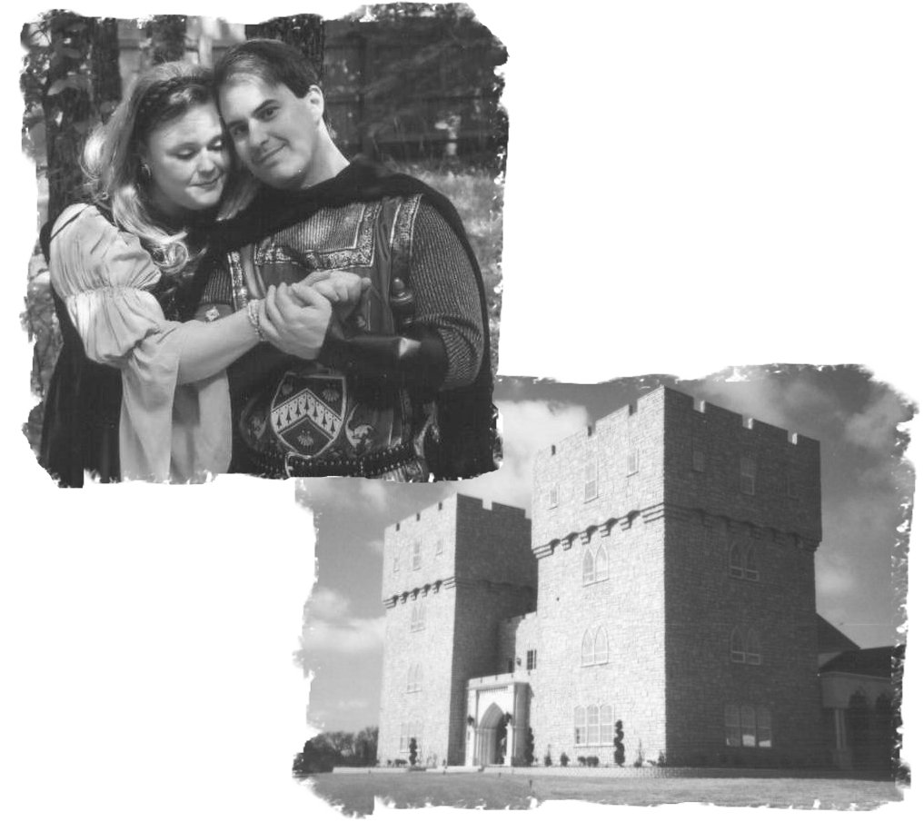


Our Story
Like two ships passing in the night
Never would this couple meet
In junior high or high school
For them this time was bittersweet
A self-proclaimed bachelor
And a maid waiting for her knight
When should these two soul mates
Find that their time was right?
It was God's hand that led them both
To the church where they'd soon meet
Still the time wasn't right, so friends they'd remain
Rather than part in defeat
Again with God's hand, drama drew them together
They grew in the Lord and in their friendship
And then came the day he asked her again,
'Shall we try a second trip?'
So on this day the maid and knight shall become one
United before all and before God and His Son
In this castle decked in royalty and music in the rafters
Join us as we say our vows and live “Happily Ever After”

Wedding Party
Parents of the Bride
Randy and Sandra Brandon
Parents of the Groom
C. William Marshall
Kay Marshall
Matron of Honor
Sandra Brandon…Mother of the Bride
Bridesmaids
Belinda McKay…Friend of the Bride
Gayle Marshall…Sister-in-law of the Groom
.Melissa Marshall…Sister of the Groom,
Ring Bearer
Ashley Marshall…Niece of the Groom
Flower Girl
Haley Marshall…Niece of the Groom
Best Man
David Olmstead…Friend of the Groom
Groomsmen
Rob Harris…Friend of the Groom
Michael Marshall…Brother of the Groom
Stephen Tsai…Friend of the Groom
Officiant
Kelly Horton…Friend of Bride & Groom
Soloist
Janet Horton… Friend of Bride & Groom
Ushers
Gary Phillips… Friend of Bride & Groom
Tracy Carmean…Friend of Bride & Groom

The Ceremony

Prelude
Presentation of Mother of the Groom
……”Two Medieval Dances”
Entrance of the Groom and Groomsmen
…..”Trumpet Voluntary”
Processional…..”Canon in D”
Entrance of the Bride…”Bride’s March”
Giving of the Bride
Pastoral Address
Lighting the Unity Candle
Bride’s solo…”Grow Old with Me”
Marriage Vows
Exchange of Rings
Janet Horton…”solo”
Holy Communion
Nuptial Blessing
Presentation of Bride & Groom
Recessional

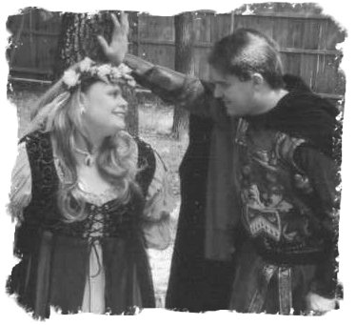
Dearest Family and Friends,

We would like to offer our heart-felt thanks to each and every one of you here with us on this special day. We are blessed to be surrounded by so many loving and caring people who have come from near and far to share in the joy and celebration of our marriage.

Thank you for your love, support, and encouragement throughout our lives and in each and every step of planning this wonderful day. In addition, we remember our loved ones who could not be with us today. They are with us in spirit and in our hearts.

Each person here has touched our lives in a very special way. We wouldn't be who we are without you. With God's help, may you all guide us and give us the strength to keep our love growing year after year. With this strength, may our love be everlasting. We love all of you so much! Thank you for sharing this day with us!

